Budget Tracker - Final Testing Plan

Purpose
This testing plan is designed to validate the completed Budget Tracker application efficiently while still touching every major feature. Each test case includes the action to perform, the expected result, and a screenshot image name for reference.

Pre-Test Setup
- Run the application from gui_v2.py.
- Use a clean test budget.db file so the expected balances are easy to verify.
- Use the required date format: YYYY-MM-DD.
- Capture screenshots after successful actions and after at least one validation/error case.
- Recommended test date set: use one past/current date, one future date, and one month-end date such as 2026-01-31.

Core Test Data
Purpose | Type | Amount | Category | Date
Starting/current income | income | 2000.00 | Paycheck | 2026-05-12
Current expense | expense | 250.00 | Bills | 2026-05-13
Future expense | expense | 900.00 | Rent | 2026-06-01
Future income | income | 2000.00 | Paycheck | 2026-06-12

Test Cases
ID | Feature / Function | Steps | Expected Result | Screenshot Evidence
TC-01 | Application Launch / Database Load | Open gui_v2.py. Confirm the Transactions tab loads and existing database rows appear if present. | Application opens without runtime errors. Transaction table loads from SQLite. | Transactions tab visible with table and summary section.
TC-02 | Add Income Transaction | On Transactions tab, select income, enter 2000, category Paycheck, date 2026-05-12, click Add Transaction. | Income row is saved, appears in the table, and current balance increases by 2000 if date is today/past. | Transaction table showing income row and updated balance.
TC-03 | Add Expense Transaction | Select expense, enter 250, category Bills, date 2026-05-13, click Add Transaction. | Expense row is saved as a negative amount internally/displayed as negative. Balance decreases if date is today/past. Category summary shows Bills: 250. | Transaction table and category summary.
TC-04 | Future Transaction Handling | Add an expense for 900, category Rent, future date 2026-06-01. | Future row appears in transaction list but does not affect current balance until its date is reached. | Transaction table showing future-dated row and current balance unchanged except current transactions.
TC-05 | Edit Transaction | Select the 250 Bills expense, click Edit Transaction, change amount to 300, click Save Edit. | Existing row updates in SQLite and table. Current balance and category summary refresh accordingly. | Updated transaction row and summary.
TC-06 | Delete Transaction | Select a test transaction that is safe to remove and click Delete Transaction. Confirm deletion. | Row is deleted from SQLite and removed from the table. Balance/category summary refresh. | Table after deletion.
TC-07 | Refresh Data | Click Refresh Transactions after adding/editing/deleting rows. | Table reloads from SQLite and summary recalculates without duplicates or errors. | Refreshed table view.
TC-08 | Input Validation - Type Dropdown | Confirm transaction type uses income/expense dropdown, not free typing. | User can only select valid transaction types. | Dropdown open or selected value visible.
TC-09 | Input Validation - Bad Date | Attempt to add/edit a transaction using an invalid date such as 05/12/2026 or 2026-99-99. | Application shows an error message and does not save the invalid transaction. | Error message box.
TC-10 | Weekly Summary View | Select a week containing current and/or future transactions. Click Load Weekly Summary. | Weekly view shows total income, total expenses, net change, starting balance, ending balance, category summary, and transactions for that week. | Weekly View tab with populated summary and transaction list.
TC-11 | Monthly Summary View | Select a month containing transactions. Click Load Monthly Summary. | Monthly view shows total income, total expenses, net change, starting balance, ending balance, category summary, and transactions for the selected month. | Monthly View tab with populated summary and transaction list.
TC-12 | Recurring Weekly Transaction | On Recurring tab, create a weekly expense with a small repeat count such as 3. | Application creates 3 future/current normal transaction rows spaced 1 week apart. | Transactions tab showing generated rows.
TC-13 | Recurring Biweekly Transaction | Create a biweekly income for 2 or 3 repeats. | Rows are created 14 days apart and appear in chronological order. | Transaction table showing biweekly rows.
TC-14 | Recurring Monthly / Month-End Handling | Create a monthly recurring transaction starting 2026-01-31 for 3 repeats. | Generated dates should handle month length correctly, such as 2026-01-31, 2026-02-28, 2026-03-31. | Transaction table showing monthly rows and corrected dates.
TC-15 | Recurring Repeat Limit Validation | Try to enter a repeat count above the allowed max: weekly > 52, biweekly > 26, or monthly > 12. | Application rejects the request with an error and does not create excessive rows. | Error message box.
TC-16 | Chronological Sorting | Add transactions in non-date order, then refresh. | Transaction table displays records ordered by date rather than by entry order. | Sorted transaction table.

Pass/Fail Criteria
- Application runs without syntax or runtime errors during normal use.
- All user-entered transactions save to SQLite and remain after restarting the application.
- Add, edit, delete, and refresh operations update both the database and GUI display.
- Current balance excludes future-dated transactions.
- Weekly and monthly summaries calculate totals and balances correctly for selected periods.
- Recurring transaction generation creates the correct number of future-dated normal transaction rows.
- Invalid data is rejected with a clear message instead of crashing the program.

Testing Screenshots
TC-01:
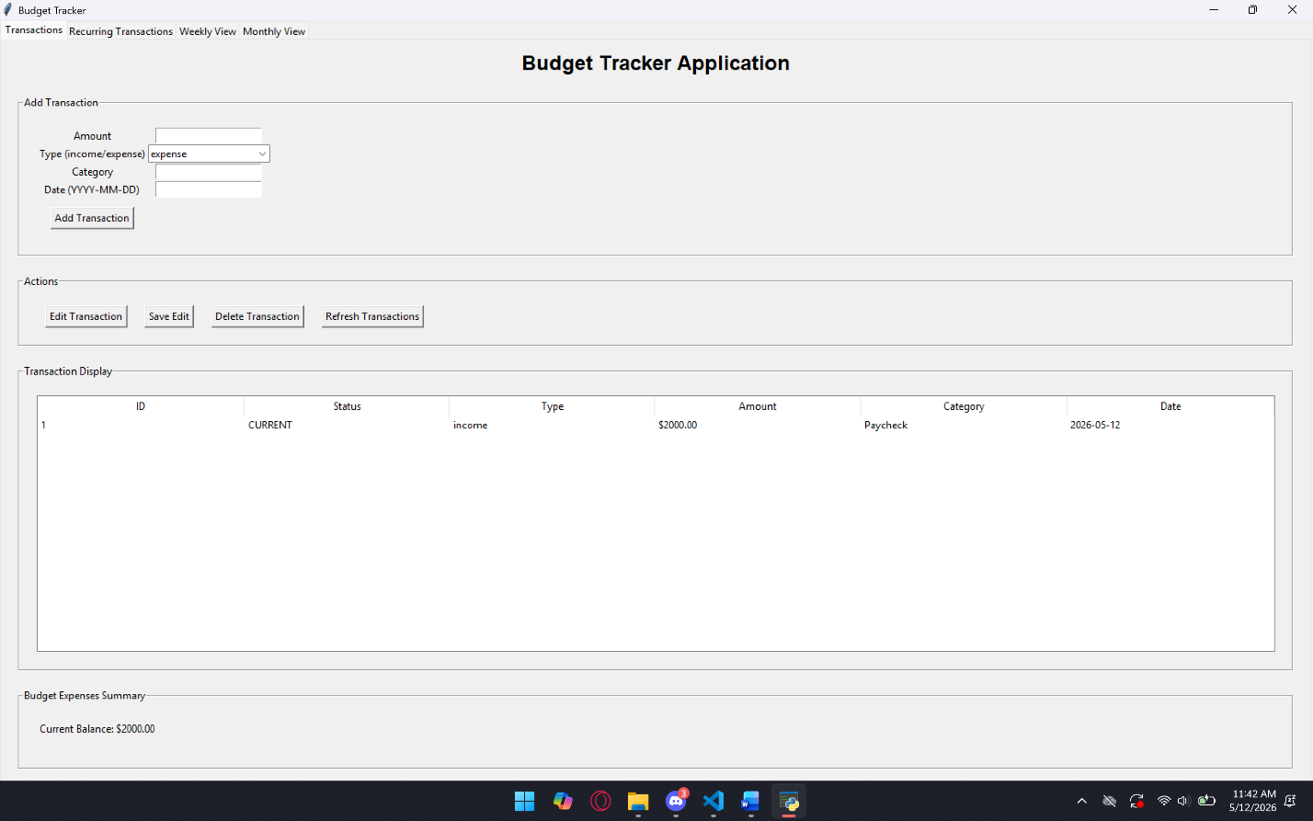
TC-02:
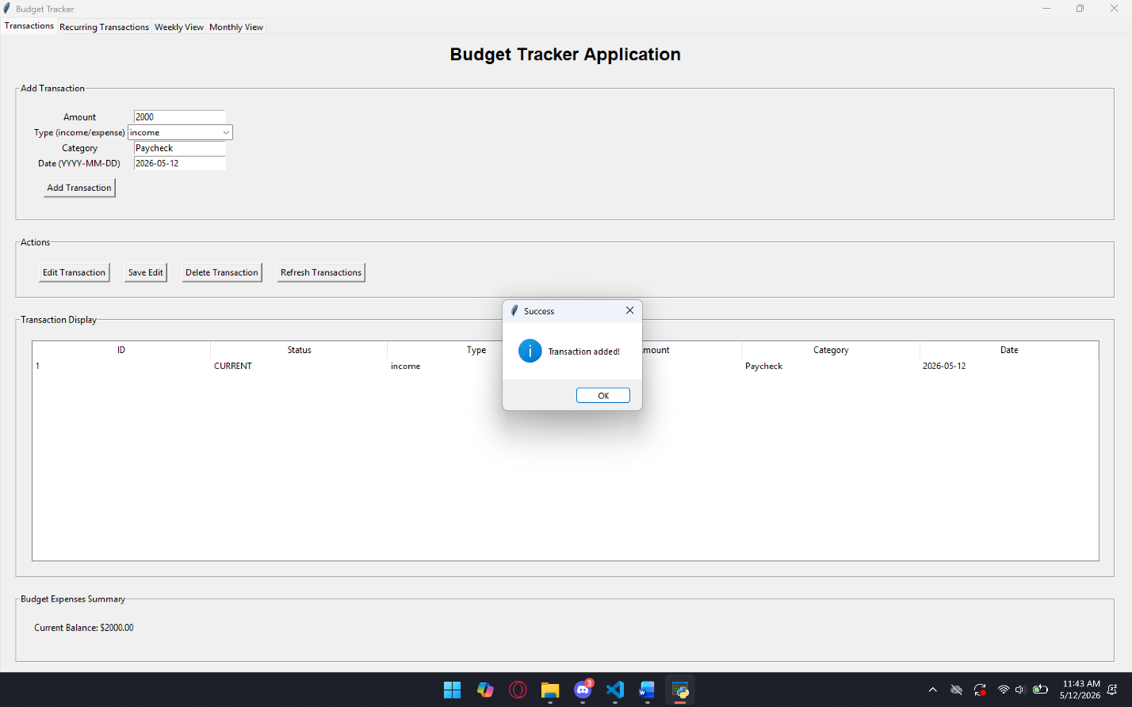
TC-03:
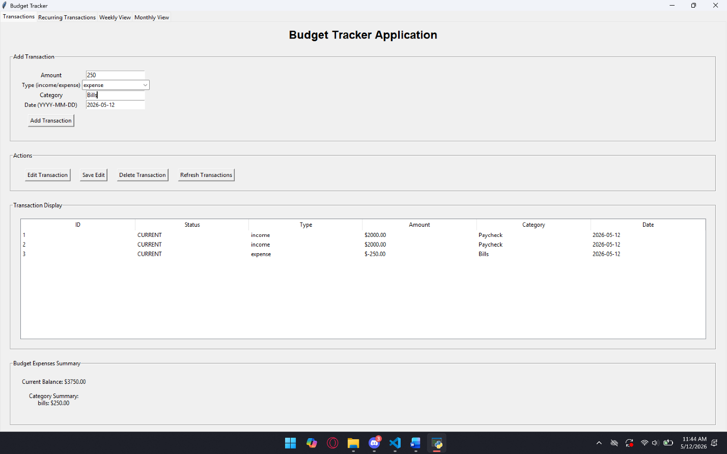
TC-04:
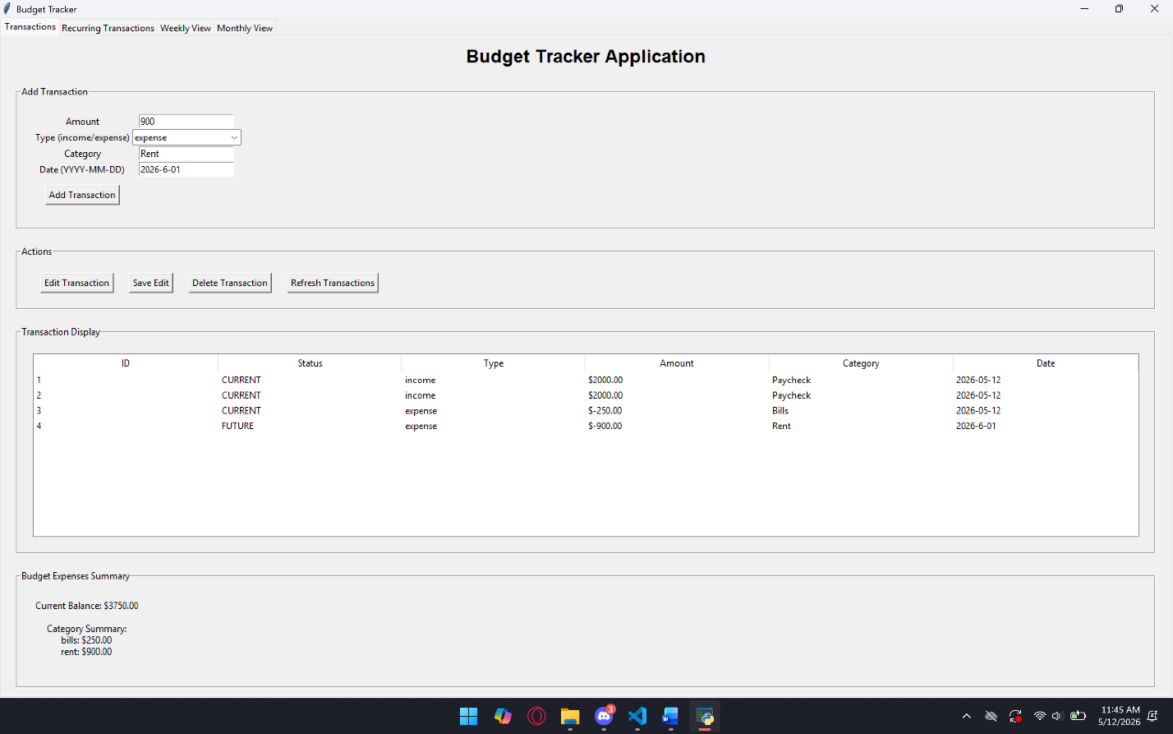
TC-05:
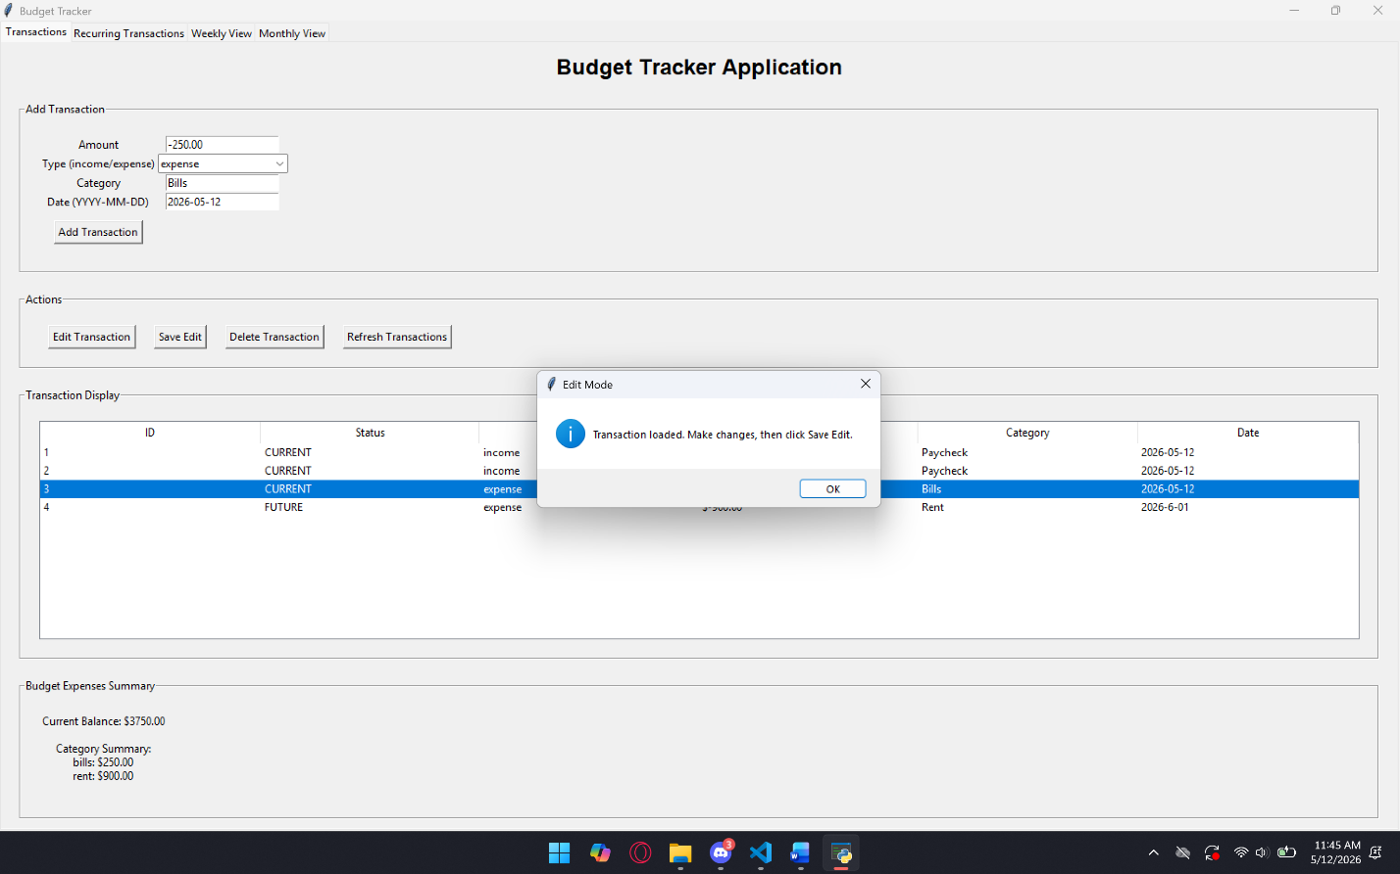
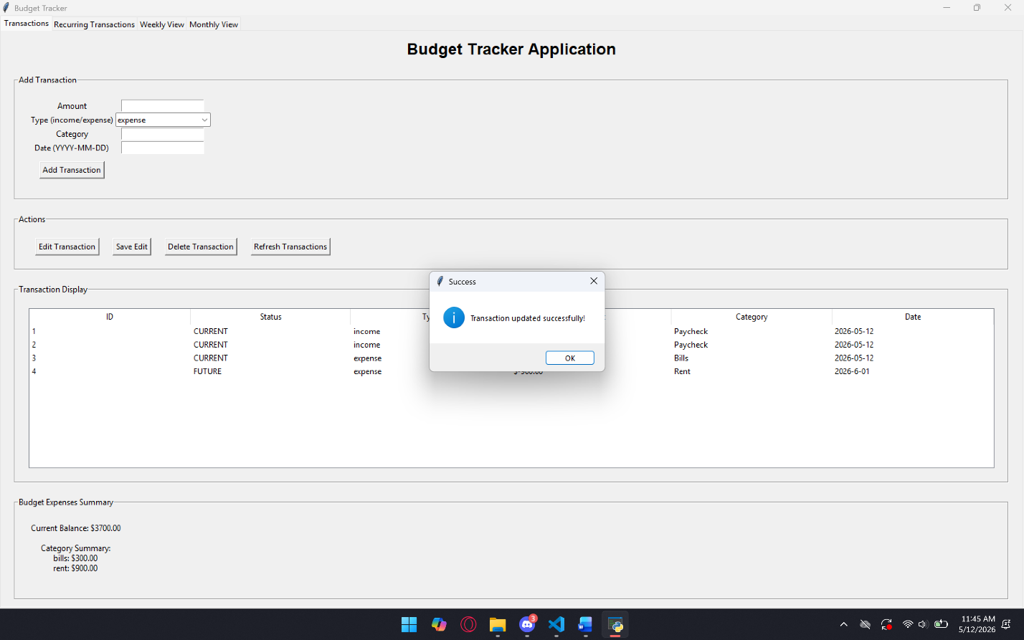
TC-06:
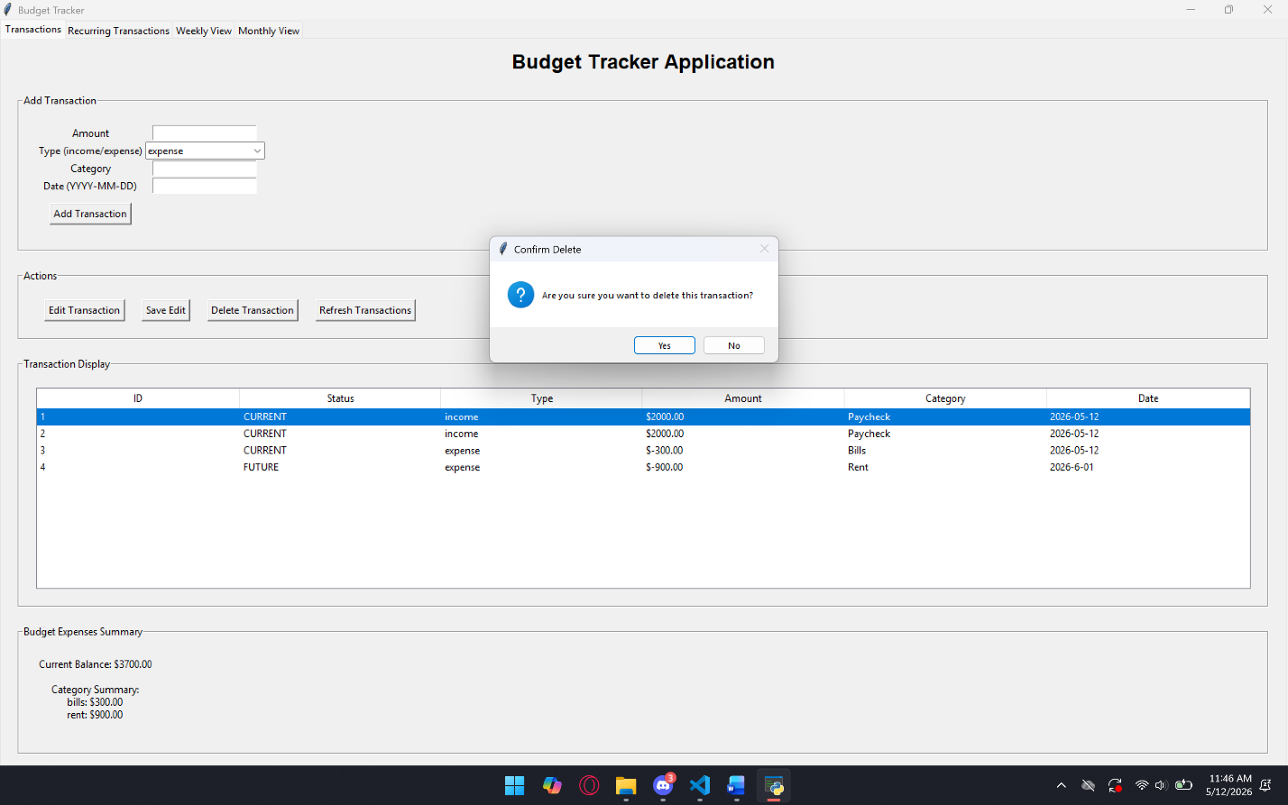
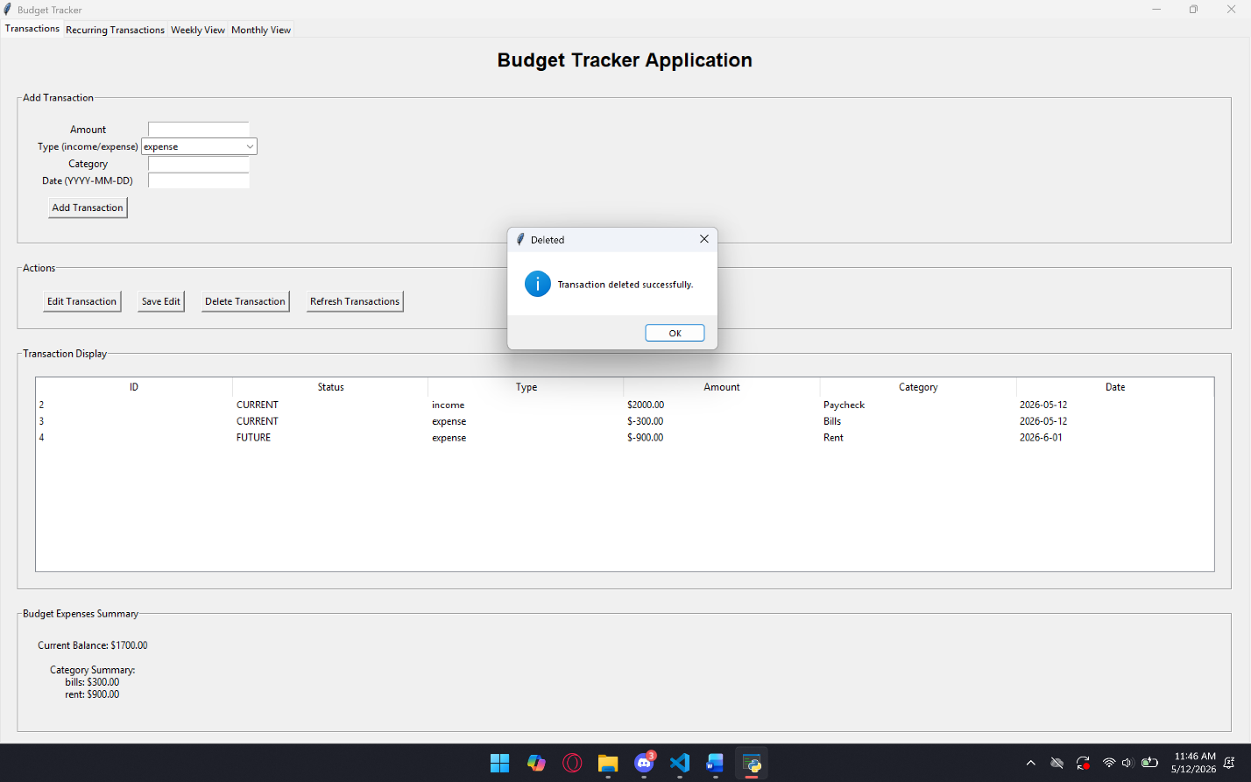
TC-07:
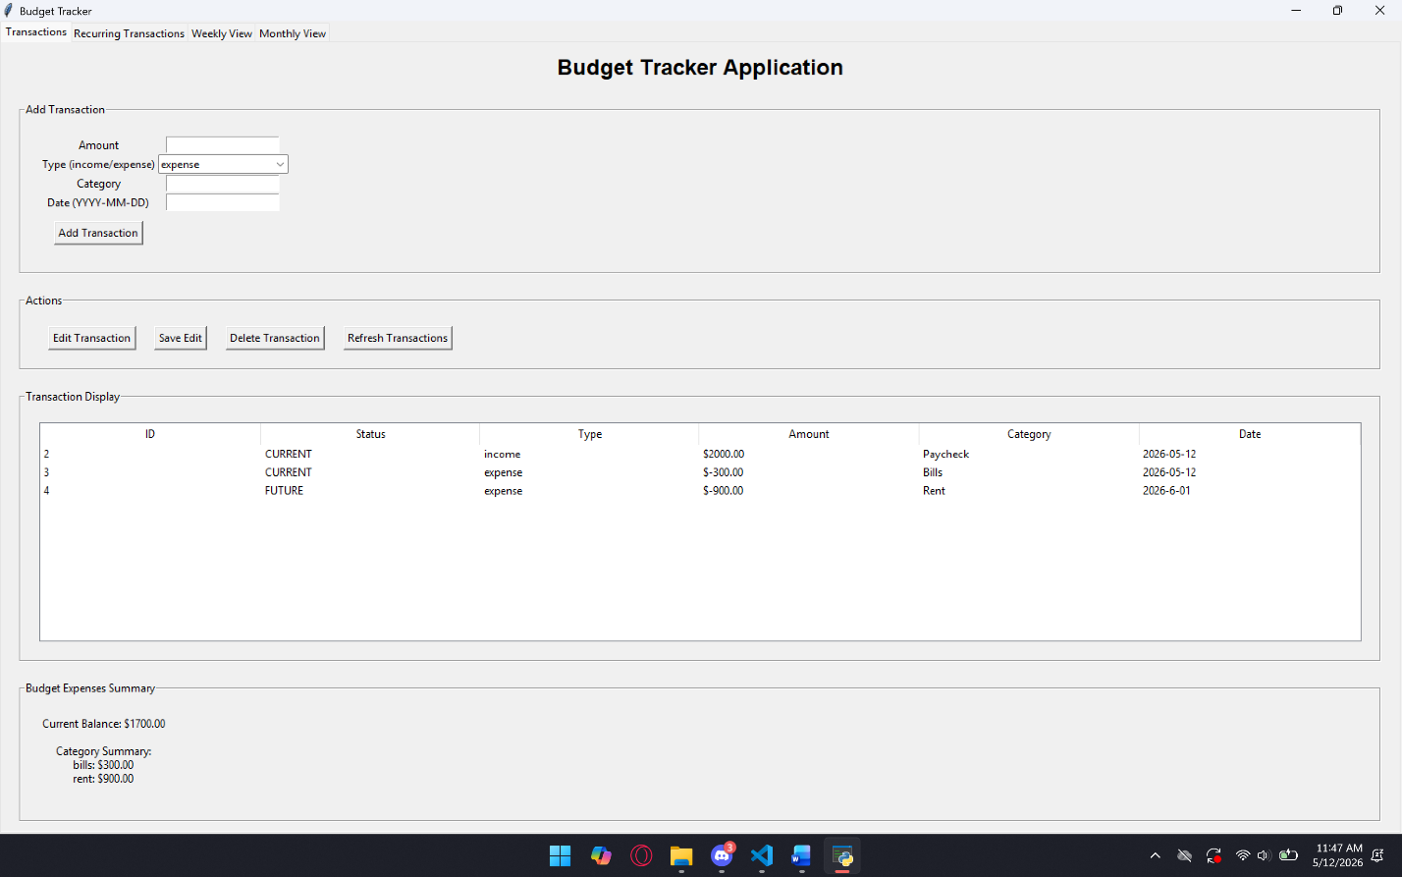
TC-08:
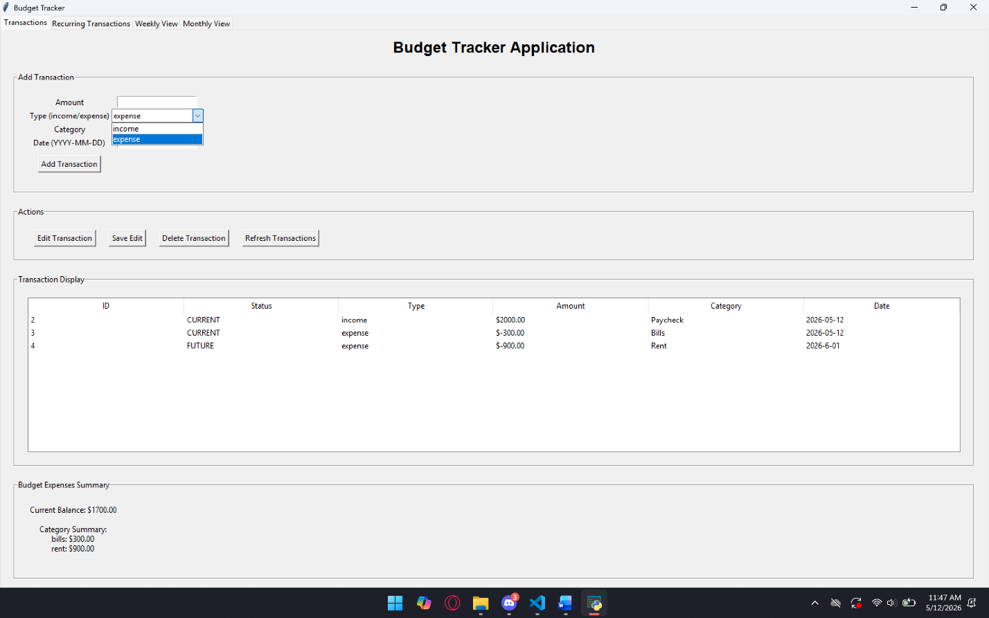
TC-09:
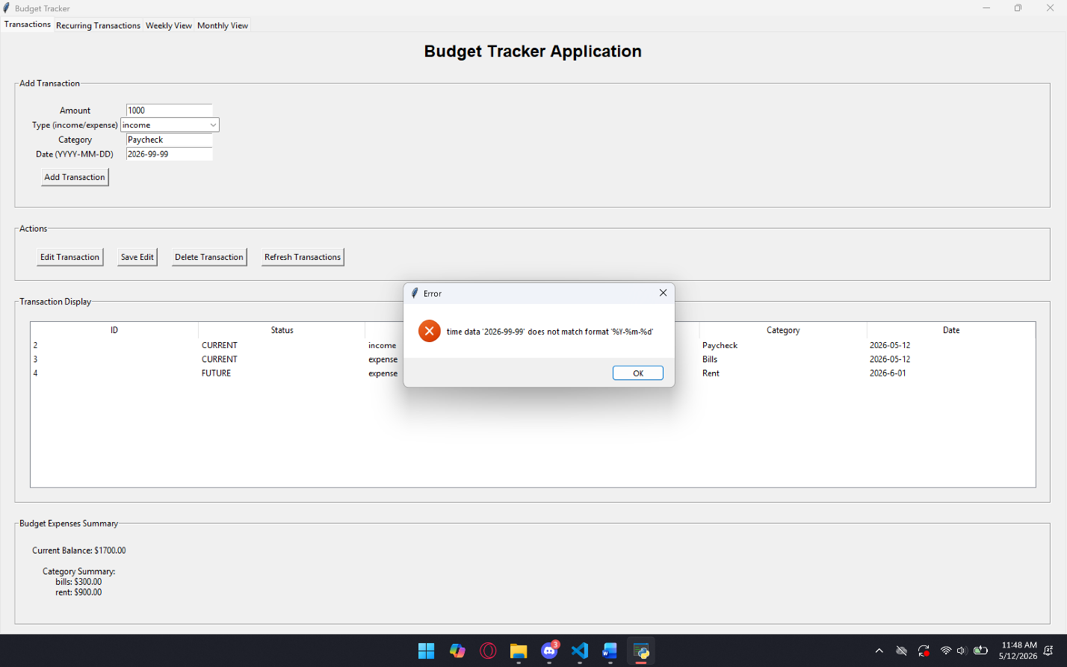
TC-10:
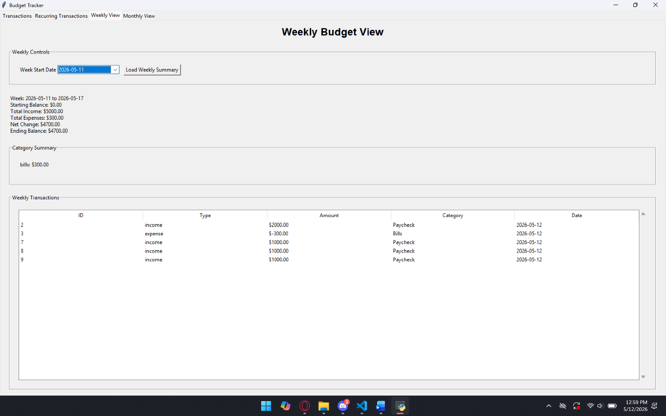
TC-11:
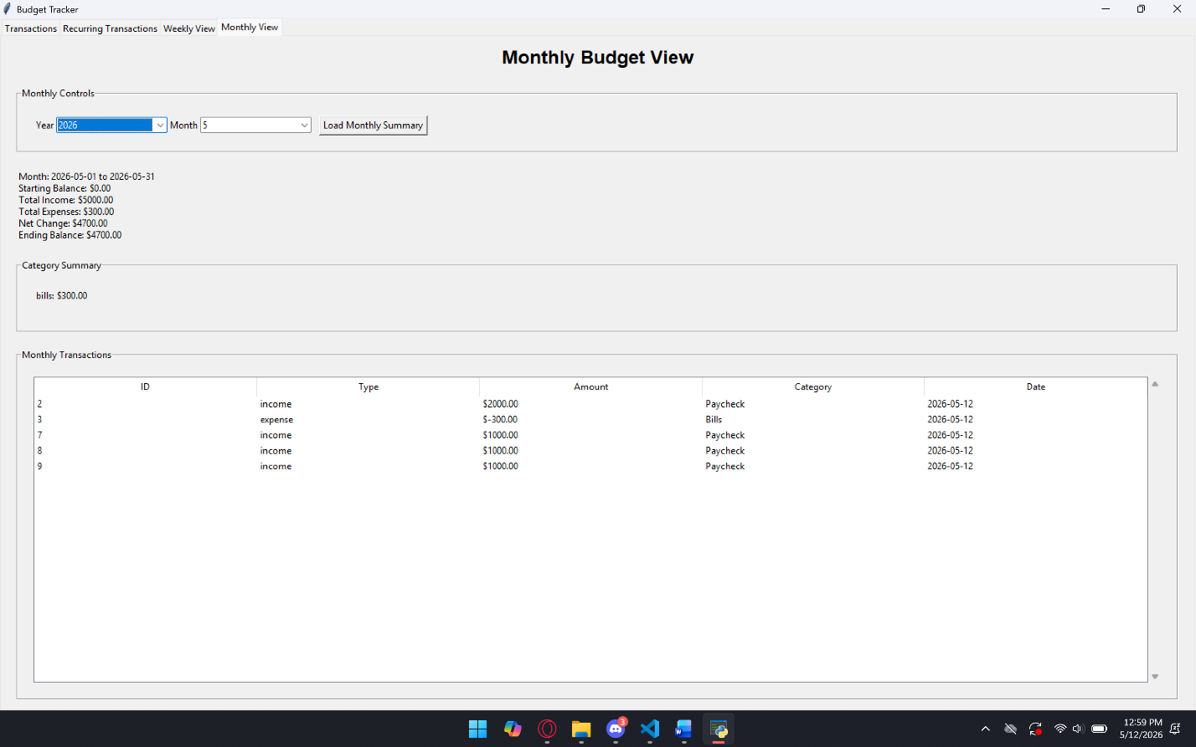
TC-12:
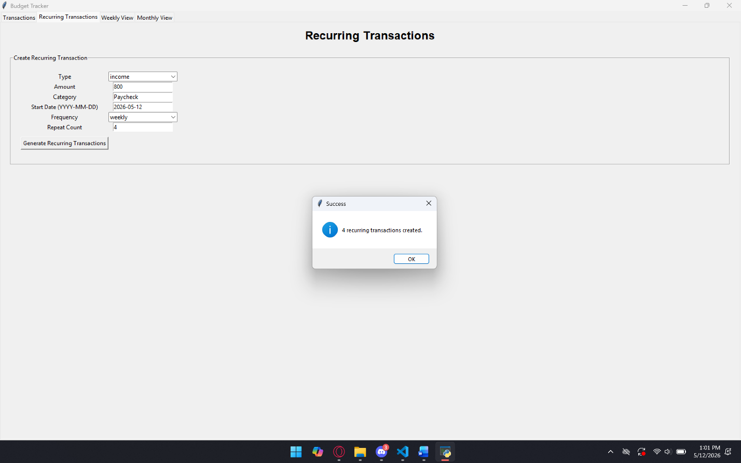
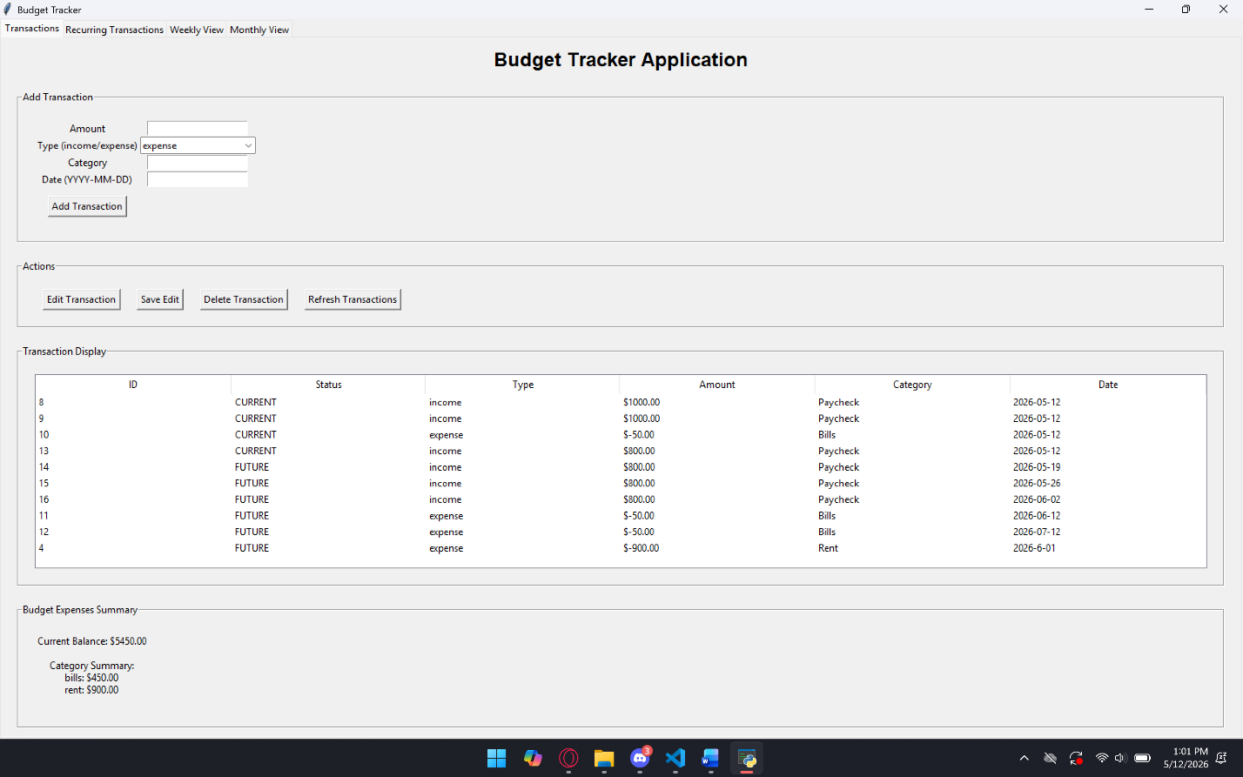

TC-13:
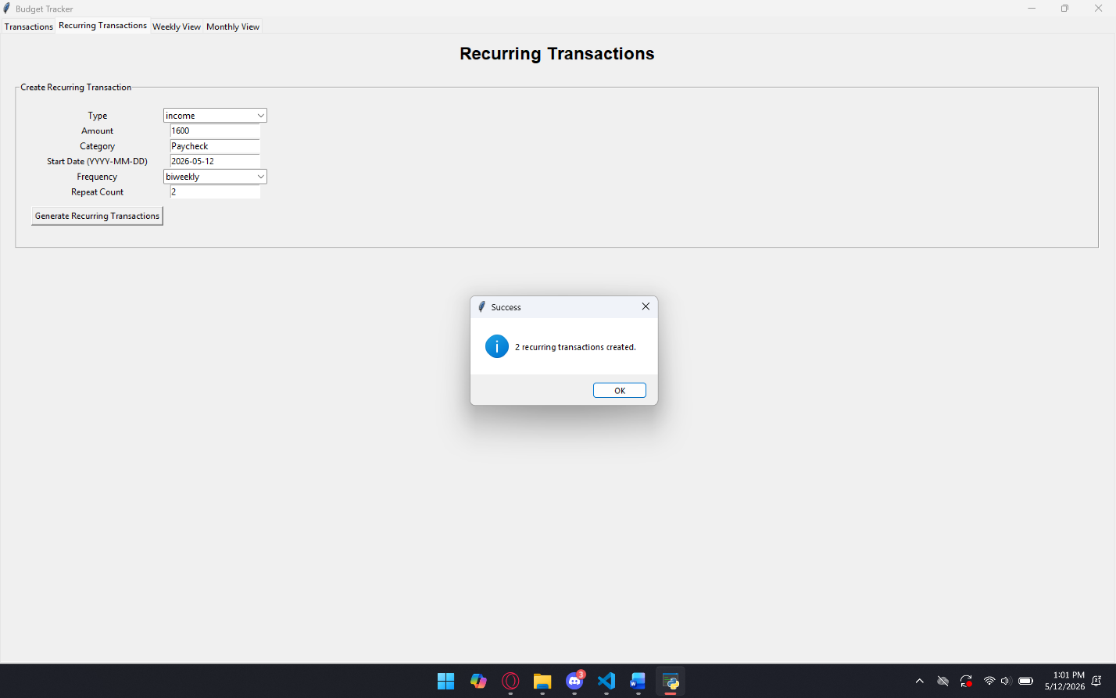
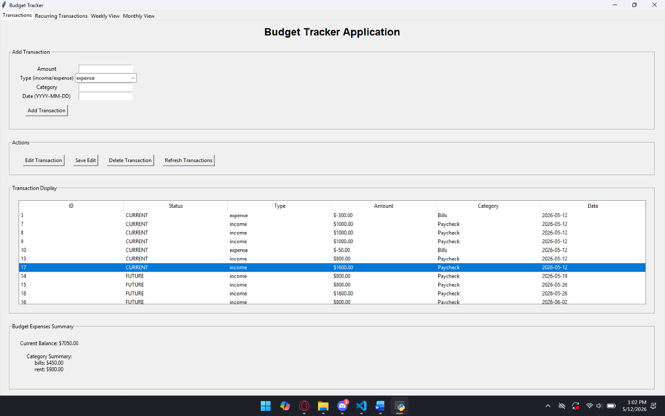
TC-14:
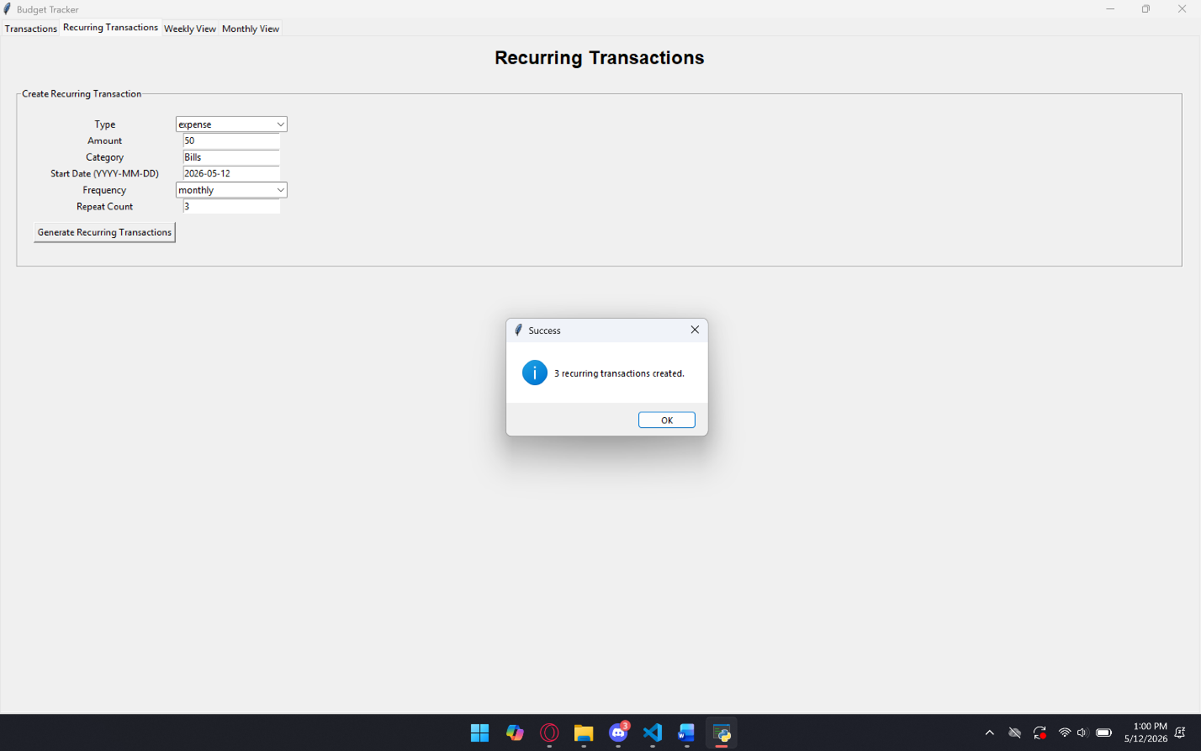
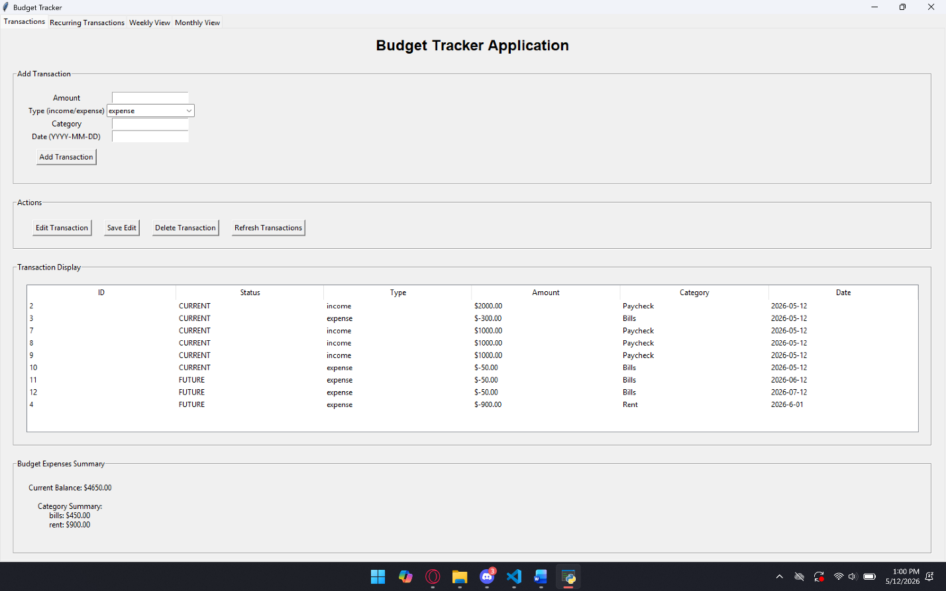
TC-15:

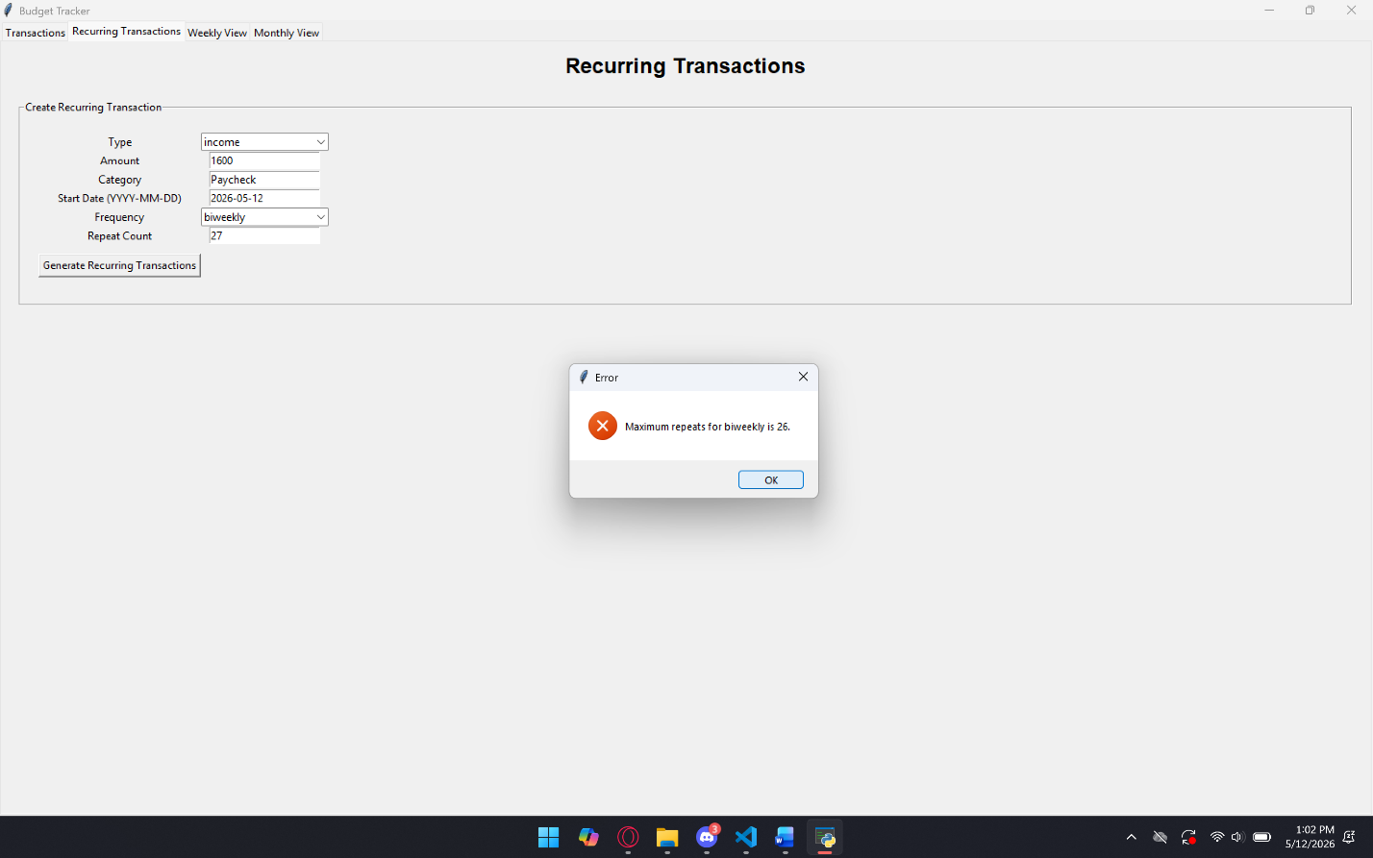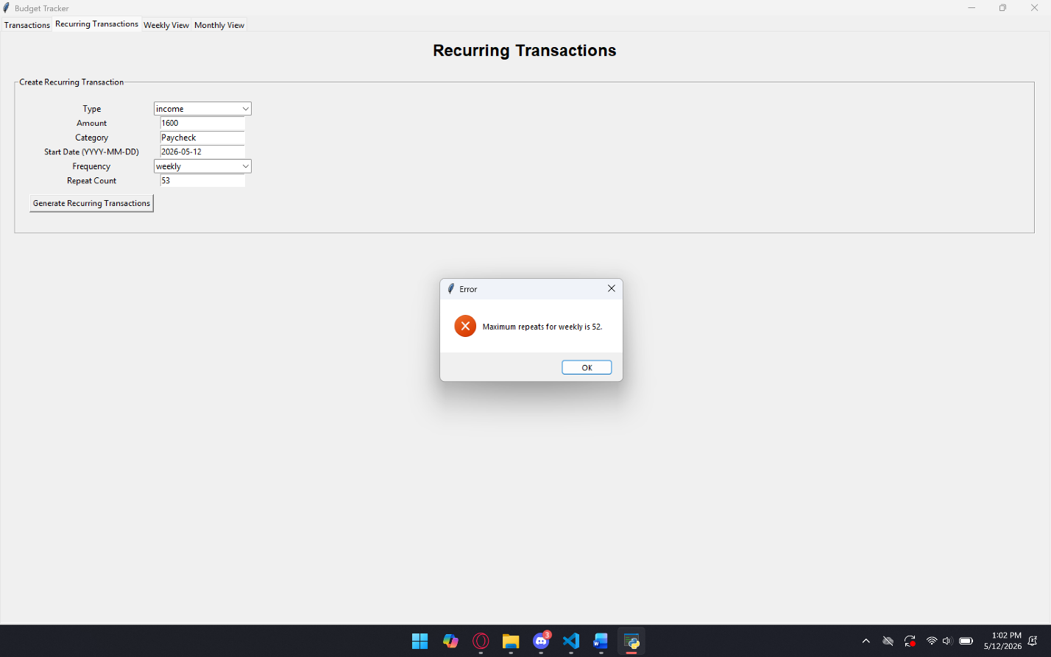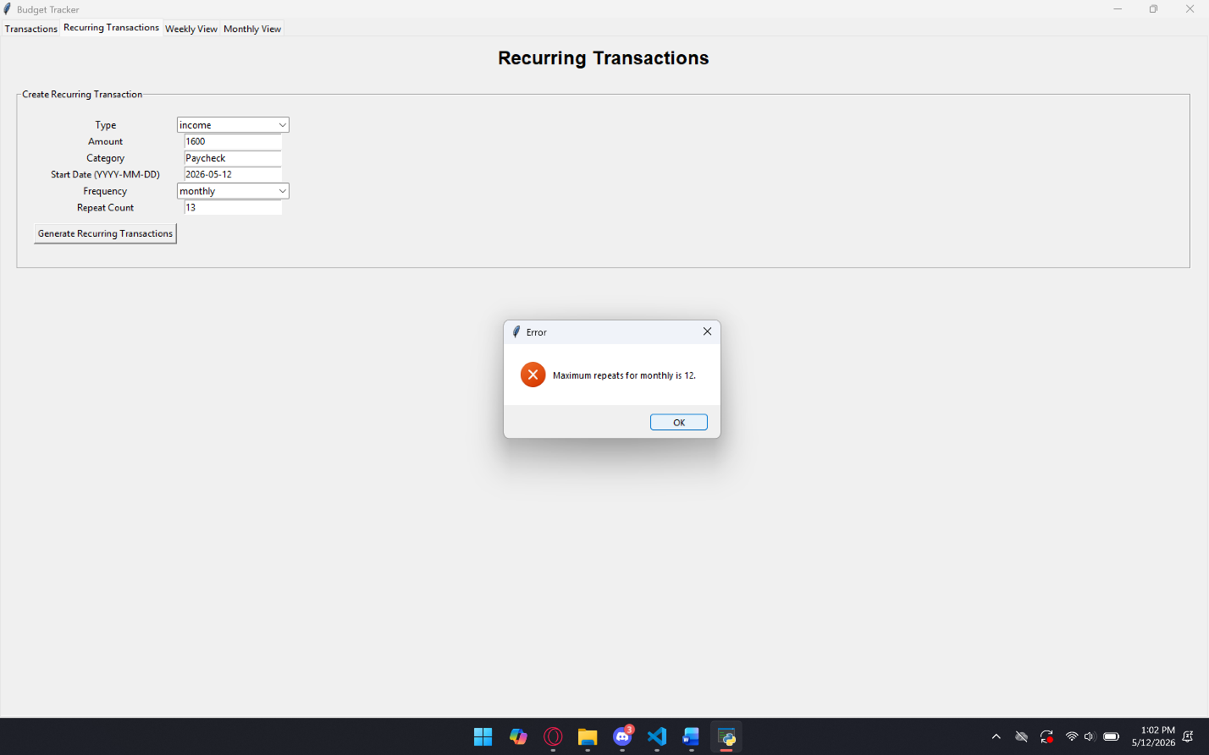

TC-16